Rodeo Survey
After today’s class:
(Check the option that most describes how you feel.)
I feel safer riding a bike. | 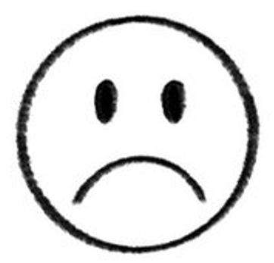  Strongly Disagree | Disagree | Agree | 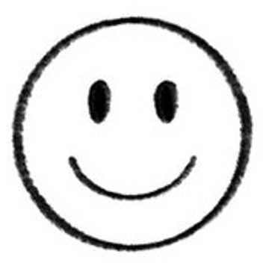  Strongly Agree
I feel more excited about biking. | Strongly Disagree | Disagree | Agree | Strongly Agree
I'd go to another biking class like this in the future. | Strongly Disagree | Disagree | Agree | Strongly Agree

Today’s class taught me (Check all that apply.):
- To wear a helmet
- Follow traffic rules
- How to show hand-signals when stopping / turning
- None of the above

Would you recommend today’s class to your friends?
- Yes
- No
- Not sure / Don’t know

Today’s class made me feel

___________________________________________________.

ABC Survey
After this workshop…
(Check the option that most describes how you feel.)
I feel safer riding a bike. | Strongly Disagree | Disagree | Agree | Strongly Agree
I feel more excited about biking. | Strongly Disagree | Disagree | Agree | Strongly Agree
I'd go to another biking class like this in the future. | Strongly Disagree | Disagree | Agree | Strongly Agree

This workshop taught me (Check all that apply.):
- To wear a helmet
- How to use the bicycle pump
- How to check bike brakes
- How to check the bike chains
- None of the above

Would you recommend this program to your friends?
- Yes
- No
- Not sure / Don’t know

This class made me feel

____________________________________________________.

